[SETTINGUP APPLICATIONENVIRONMENT](https://careereducation.smartinternz.com/Student/guided_project_workspace/38367#collapse1)

CreateIBMCloudAccount

|  |
| --- |
| Date: 10 November 2022 |
| TeamID:PNT2022TMID50435 |
| ProjectName: SmartFashionRecommenderApplication |

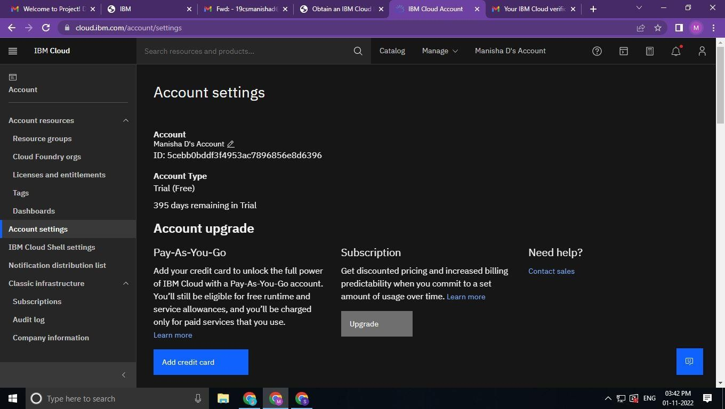

IBMCloudAccounthasbeencreated.